Java Project Report

TODO

* Advance search by

|  |  |  |
| --- | --- | --- |
| Type | Meaning | Example |
| -m | Title | -m Titanic |
| -y | Year | -y 2016 |
| -r | Ratings | -r 4.5 |
| -t | Tags | -t Drama,Comedy |
| /i | Inclusive | -t /i Drama = tags include Drama |
| /x | Exclusive | -t /i Drama = tags exclude Drama |
| < | Less than | -y <2016 |
| > | Greater than | -r >4.0 |
| | | Between | -r 4.0|5.0 |
|  |  |  |

* Login System Registration User Favorite
* Time Stamp getter
* Add/remove rating
* File update& output

Home

Register

Login

Search

Edit User Info

Rate Movie

Features

System

Class Explanation

User

Movie

Rating

Rating

String: Title

String: Username

Int: UserID

Bugs:

-year 1990-0?? >> typed between 1990-2020 🡪 searched 1990-0

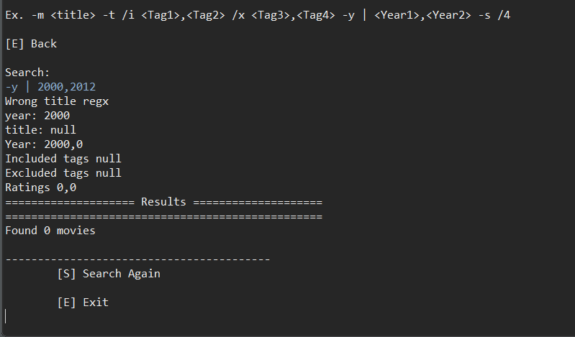

-year >> problem SURE

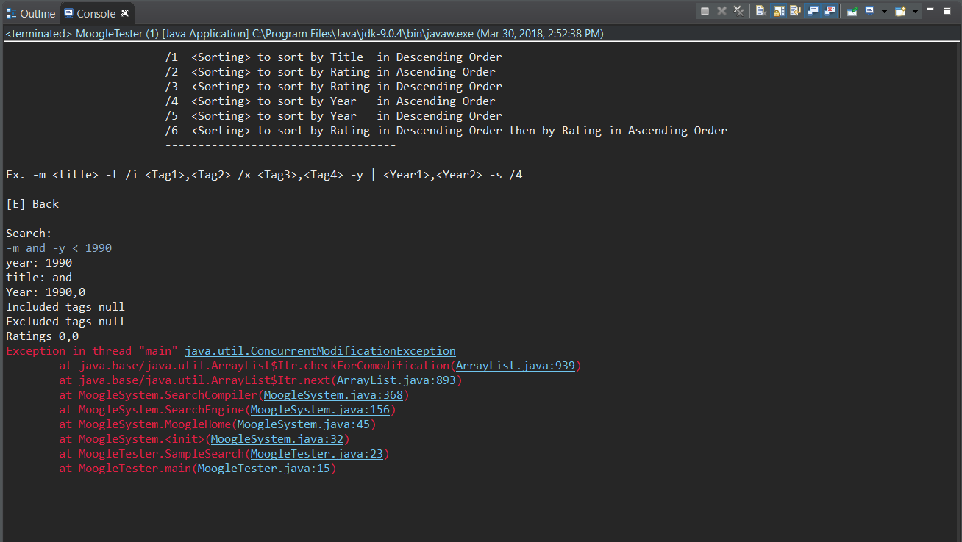

-rating (ใช้ไม่ได้เลย)

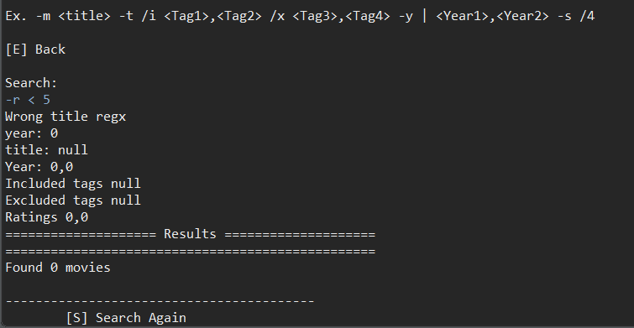

Classes

Movies

Users

Ratings

Moogle System (home)

* Read all file

MoogleRegis

MoogleLogin

MoogleSearch

MoogleRate

MoogleUser

MoogleIO